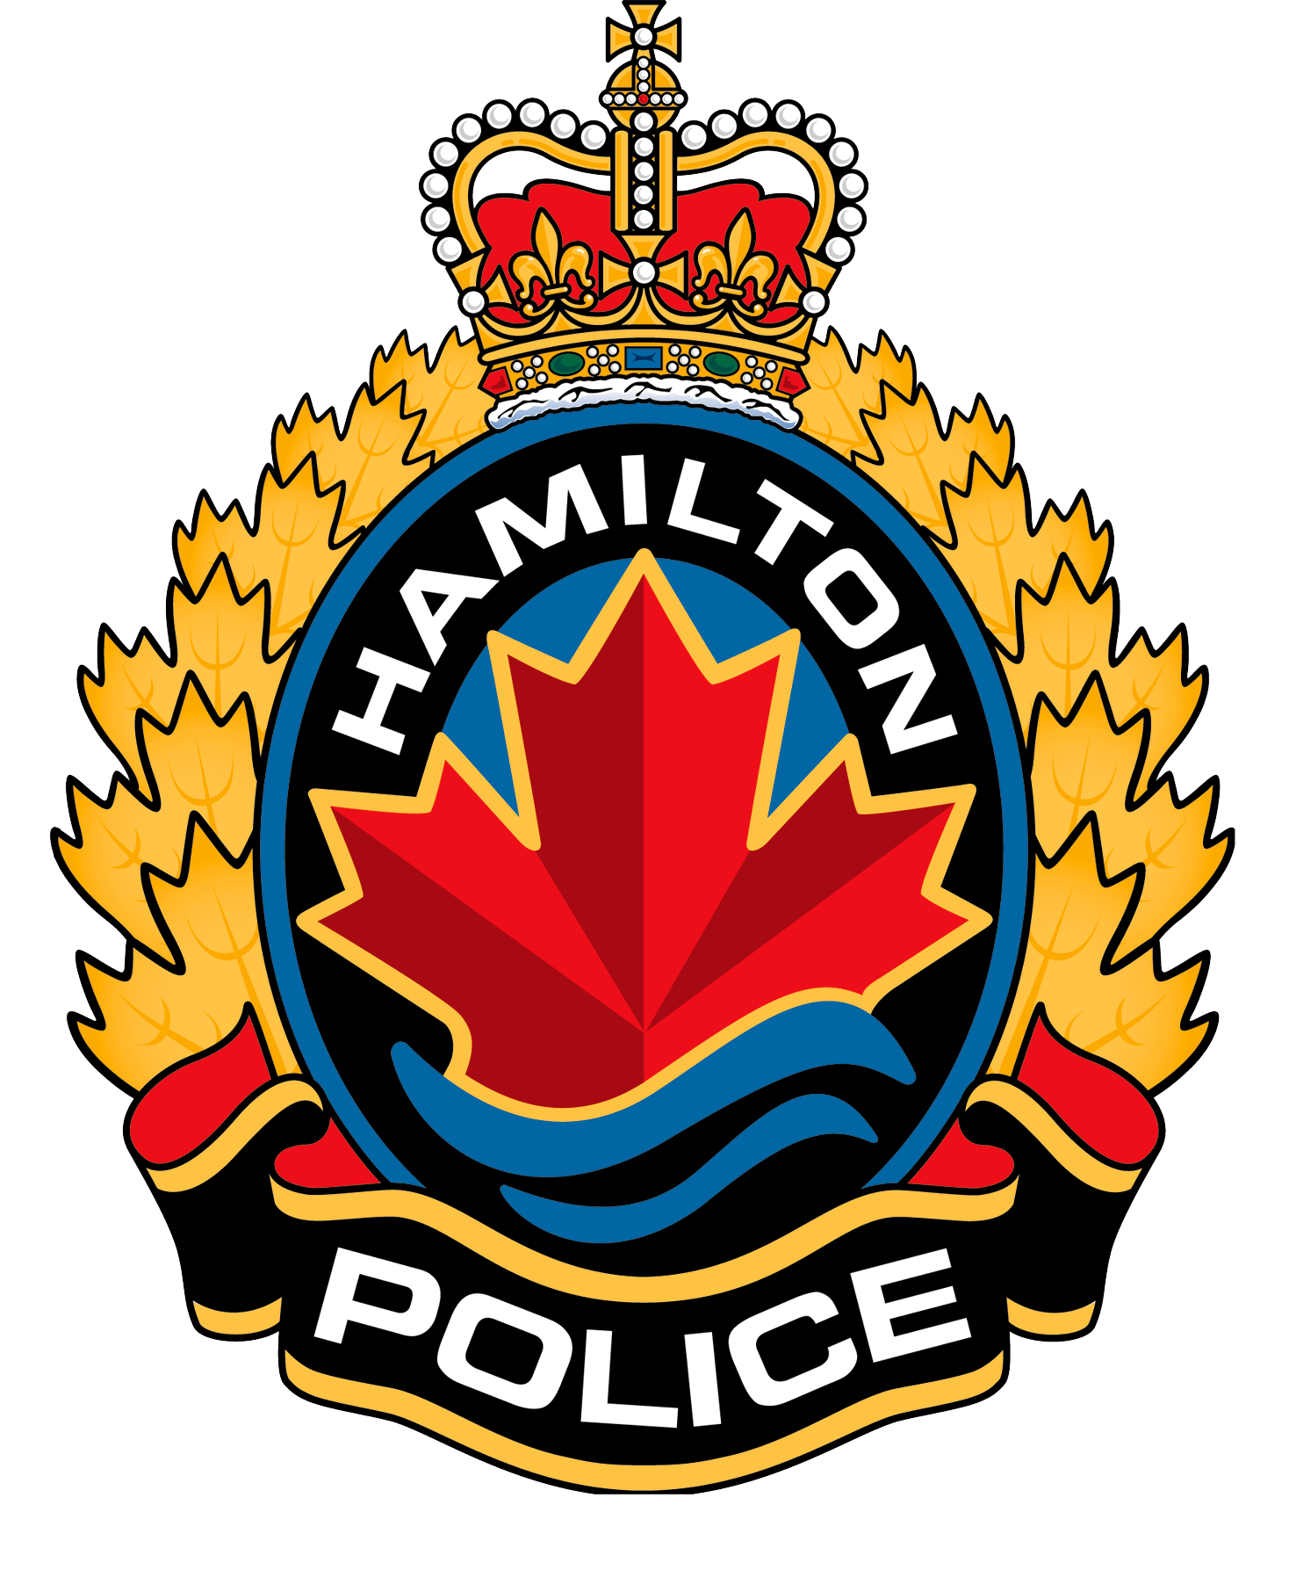

HAMILTON POLICE SERVICES BOARD

Board Members
FOR IMMEDIATE RELEASE

December 7, 2020
Fred Eisenberger, Chair
Fred Bennink, Vice Chair
Mel Athulathmudali
Chad Collins
Robert Elms
Tom Jackson
Patricia Mandy

Kirsten Stevenson, Administrator

HAMILTON, ON – The Hamilton Police Services Board is hosting two virtual town hall events to engage the broader community on policing issues. The virtual town halls will take place on Wednesday, January 13 and Thursday, January 14, 2020 from 8:00 – 9:00 pm and will be live-streamed to the Hamilton Police Facebook page: https://www.facebook.com/HamiltonPolice/.
It is important for the Board to understand the needs and concerns of Hamilton residents to help support initiatives and address matters that impact the entire community. These virtual town hall events will provide the Board with an opportunity to hear directly from the public on matters such as community safety priorities, accountability and reform. Participants will have the opportunity to answer live polls, ask questions and provide comments on policing topics relevant in today’s society.
Residents will be able to participate in these events through a completely randomized call out process managed by The Prime Contact Group. The list of numbers to be called randomly will be comprised of City of Hamilton landlines. Residents who do not have a landline and wish to have their contact number included in the randomized call out pool may register their number at www.hpsbpublicmeeting.com, no later than 4:00 p.m. Monday, January 11, 2020. Shortly before the beginning of each virtual town hall, randomly selected participants will be contacted and asked if they would like to participate. All contact information gathered will be maintained by The Prime Contact Group and will not be kept following the virtual town hall events.
Results of both virtual town halls will be compiled by The Prime Contact Group and provided to the Board for review at the next possible public board meeting. These results will be made available to the public via the Board’s website at https://hamiltonpolice.on.ca/about/police-services-board/presentations-and-reports.
At the Hamilton Police Service, our vision is to be a trusted partner in delivering public safety in partnership with our communities and we value your comments and feedback.

For more information, please contact:
Kirsten Stevenson,
Board Administrator
kirsten.stevenson@hamilton.ca
www.hamiltonpolice.on.ca/about/police-services-board

