HAMILTON POLICE SERVICE
BOARD

2026 BOARD BUDGET PACKAGE

INDEX
1. Board Budget at a Glance 3
2. Board Budget in Detail 4
3. One-time Costs Impacting the Board’s Budget for 2026 6
4. What is the Role of the Hamilton Police Service Board? 8
5. The Purpose of Preparing the 2026 Board Budget Package 9
6. A New Way of Presenting the 2026 Board Budget 10
7. The Role of City Council in the Budget Process 11
8. (For) More Information 13
9. 2025 Approved Board Budget 15

Board Budget at a Glance
This information relates to Board expenses only – the Police Budget is part of a separate budget.
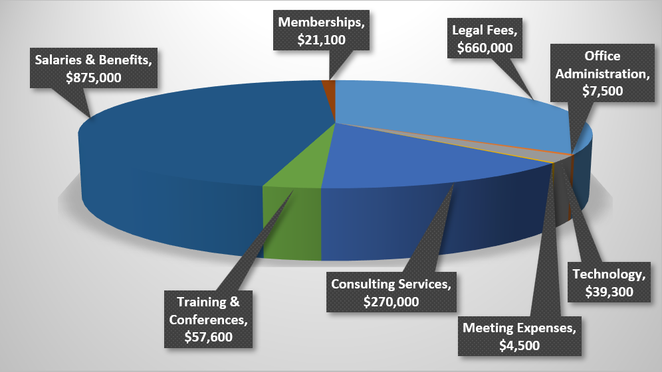
Account Type | Cost | Percentage of Total Budget
Consulting Services | $270,000 | 14%
Legal Fees | $660,000 | 34%
Meeting Expenses | $4,500 | >1%
Memberships | $21,100 | 1%
Office Administration | $7,500 | 1%
Staff Salaries & Benefits | $875,000 | 45%
Technology | $39,300 | 2%
Training & Conferences | $57,600 | 3%
Total | $1,935,957

Board Budget in Detail
The Board’s budget was approved at their July 2025 special meeting.
The information below is a listing of the types of expenses that are found in each account type.
Consulting Services
These costs are associated with instances where the Board requires a specialized individual or company to assist with Board business. For example, when preparing for the Board’s next Strategic Plan, the Board will be hiring an expert to lead the development, process, public consultations and other matters required under the Community Safety and Policing Act and its Regulations (The Act) when building a strategic plan. Other consulting services may be needed when recruiting for a new Chief of Police or other similar senior position such as Deputy Chief.
Legal Fees
The majority of our legal fees relate to the following: grievances, arbitrations, WSIB claims, legal indemnification of members, legal advice (expert review of Board policies & procedures, complaints, interpretation of The Act, preparation of contracts, and other legal issues as they arise). The Board is a separate entity from the City of Hamilton, and therefore must use its own specialized legal counsel. Although we do our best to estimate the budget required to pay these costs on a yearly basis, sometimes unforeseen matters come up that deplete our budget used to pay these expenses.
Meeting Expenses
Costs associated with holding meetings, which include room supplies for set-up and meals when work is expected to take place over regular meal breaks.
Memberships
Membership fees include Board participation in Canadian police governance organizations such as the Canadian Association of Police Governance and Ontario Association of Police Service Boards. Membership in these associations provide the Board with access to training, education, webinars, templates, information and advice shared by other police Boards. Membership also provides a cost savings when signing members up for attendance at conferences.
Office Administration:
These expenses are general costs to run the Board’s office. Items include office supplies, printing, postage and Board staff equipment.
Staff Salaries & Benefits:
These funds are used to pay the salaries and benefits of Board staff. In 2026, the Board will be adding a third full-time member to their staff compliment. The number of staff working for the Board, as well as their salaries and benefits, are in line compared to other Police Service Boards similar in size to Hamilton. Based on s.220 of The Act, in 2026 the Board will also be responsible for paying salaries and benefits for two Senior Civilian Police members who will become direct employees of the Board. The Board has approved a policy on this matter and will post this information on our website in the near future.
Technology:
Technology costs includes the purchase and maintenance of software used to run the Board’s agenda management system and public website.
Training & conferences:
Although Board members participate in mandatory training, as noted in The Act, members attend training and conferences to continue to educate themselves on trends in Canadian policing and governance as well as other important matters. The Board also arranges specific training for their members related to the impact of certain Acts and Regulations on policing governance as well as to understand the implications of the Police Service Board Member Code of Conduct. Training is ongoing and an important goal of the Board.

One-time Costs Impacting the Board’s Budget for 2026
Key Points

- The Board’s 2026 budget is substantially higher than in 2025 due to one-time costs planned for 2026:
    - Preparing for a new Strategic Plan for 2027 – 2030;
    - Public and Service member consultation respecting hiring the next Chief of Police.
- In past years, Board staff costs were listed in the Police budget. Starting next year (2026), Board staff costs will be added directly to the Board’s budget, which also explains an increase to the Board’s 2026 budget.
Details

- Preparing for a New Strategic Plan for 2027 – 2030
Based on The Act s.39(5), the Board must review and, if appropriate, revise the Strategic Plan in accordance with the regulations, if any, at least once every four years. The current Board Strategic Plan is valid until the end of 2026. According to rigorous requirements listed in The Act respecting how the Board must prepare, conduct consultations and publish their Strategic Plan, the Board must start the planning process immediately to ensure compliance with The Act.

- Hiring the Next Chief of Police
When the Board is considering hiring its next Chief of Police, they look to the public, community groups and Hamilton Police Service members for their feedback on what qualities they would like to see in the next Chief of Police, as well as what issues and challenges they believe the Service will be facing in the upcoming years.
In an effort to gather feedback, the Board arranges townhall meetings as well as public and internal (for members of the Service) anonymous surveys. The Board then takes analysis from this feedback into consideration during the search, interview and hiring process.
Costs involved in this process pertain to:
  - hiring of an external consultant to lead the Board in recruiting a new Chief;
  - assisting with gathering and interpreting public and internal feedback; and
  - leading the Board through the interview and hiring process

What is the Role of the Hamilton Police Service Board?
Key Points

- The Board must ensure ‘adequate and effective policing’ is provided for everyone in Hamilton – the Board does this through its policies
- The Board is an independent organization made up of 7 civilians that govern and oversee the Hamilton Police Service (Service)
- The Board takes its direction from The Act and its Regulations
Details

The (Board) is the civilian governing body responsible for the oversight of the Service and for ensuring the provision of adequate and effective police services in Hamilton. It does this through the application of policies and regular reporting from the Service, as mandated and provided for in The Act. The Chief of Police reports to, and is directly accountable to the Board for adherence to and compliance with the Board’s policies. In essence, the Board is the trustee of public interest respecting the provision of all police services in the community. The Board ensures policing in Hamilton reflects the needs, values, and expectations of our community. It sets strategic priorities, develops policies, oversees the budget, and monitors the effective management of the Service. Through this role, the Board promotes transparency, supports meaningful community engagement, and strengthens public trust in local policing.

The Purpose of Preparing the 2026 Board Budget Package
Key Points

- To educate the public on what the Board is responsible for
- To be transparent in the costs required to run the Board in performing its responsibilities to govern the Service and make certain ‘adequate and effective policing’ is provided to everyone living in Hamilton
Details

In ensuring its responsibilities are met under The Act as well as its Regulations, the Board wishes to be transparent as to what the costs are to run the Board and govern the Hamilton Police Service.
The Board releases its budget every year and it is made available to the public as part of the Police Budget as a whole.
During future budget cycles, the Board pledges to provide a breakout of the Board’s budget, separate from that of the Police Budget, for viewing by all members of the public.

A New Way of Presenting the 2026 Board Budget
Key Points

- This is the first time the Board will be presenting its budget separate from that of the Police Service
- The Board’s budget shows the costs associated with performing its duties as noted in The Act
Details

In past years, the Board’s budget was built into the Police budget. The Board recently made the decision to separate both budgets for the upcoming budget cycle (2026) to show a clear delineation between what costs are associated with running the Board (governance) versus running the Police Service (operations).

The Role of City Council in the Budget Process
Key Points

- The Board is responsible for preparing and presenting its budget, as well as the police budget, to City Council
- City Council either approves or rejects these budgets
- If City Council rejects the budgets, the Board can request an arbitration or the Board and City may enter into mediation
Details

Under ‘Section 50: Municipal Board Finances’ of The Act:
- A municipality that maintains a municipal board shall provide the board with sufficient funding to,
- comply with this Act and the regulations; and
- pay the expenses of the board’s operation, other than the remuneration of board members.
- A municipal board shall submit operating and capital estimates to the municipality that will show, separately, the amounts that will be required to,
- comply with this Act and the regulations, including the amounts required to provide the police service with required equipment and facilities, having regard for the various ways that the board can discharge this obligation; and
- pay the expenses of the board’s operation, other than the remuneration of board members.

- The format of the estimates, the period that they cover and the timetable for their submission shall be determined by the municipality.
- Upon reviewing the estimates, the municipality shall establish an overall budget for the municipal board for the purposes described in clauses (1) (a) and (b) and, in doing so, the municipality is not bound to adopt the estimates submitted by the municipal board.
- In establishing an overall budget for the municipal board, the municipality does not have the authority to approve or disapprove specific items in the estimates.
- If the municipal board is not satisfied that the budget established for it by the municipality is sufficient for the purposes described in clauses (1) (a) and (b),
- the municipal board and the municipality may jointly apply to the Commission Chair to appoint a conciliation officer to attempt to resolve the matter; or
- the municipal board may give the municipality written notice referring the matter to arbitration.

(For) More Information
If you are not able to locate the information you are looking for on our website or in this Board budget package, please contact the Board’s Executive Director at: kirsten.stevenson@hamilton.ca.
Detailed information about the Board may be found on our website at www.hamiltonpsb.ca.
For information related to past budgets, please visit: https://www.hamiltonpsb.ca/reports-and-policies/hamilton-police-budgets/
Roles and Responsibilities of the Board
The Board is the civilian body governing the Hamilton Police Service. The board is responsible for ensuring the delivery of adequate and effective policing in Hamilton and to provide accountability to the public through governance activities that contribute to locally responsive policing.
The primary role of the board is to establish, after consultation with the Chief of Police, overall objectives and priorities to ensure requirements found in the Community Safety and Policing Act are met or exceeded. This is achieved through the enactment of policies.
The Board cannot direct the Chief with respect to specific day to day or operational decisions of the Service.
Legislated Responsibilities of the Board
The Community Safety and Policing Act outlines the following responsibilities of the board:
A Police Service Board shall:
- ensure adequate and effective policing is provided in the area for which it has policing responsibility;
- employ members of the police service;
- appoint members of the police service as police officers;
- recruit and appoint the chief of police and any deputy chief of police and determine their remuneration and working conditions, taking their submissions into account;
- prepare and adopt a diversity plan to ensure that the members of the police service reflect the diversity of the area for which the board has policing responsibility;
- monitor the chief of police’s performance;
- conduct a review of the chief of police’s performance at least annually in accordance with the regulations made by the Minister, if any;
- monitor the chief of police’s decisions regarding the restrictions on secondary activities set out in section 89 and review the reports from the chief of police on those decisions;
- monitor the chief of police’s handling of discipline within the police service;
- ensure that any police facilities, including police lock-ups, used by the board comply with the prescribed standards, if any; and
- perform such other duties as are assigned to it by or under this or any other Act, including any prescribed duties.

2025 Approved Board Budget

2025 Approved Board Budget List by Account Type
Account Type | Cost | Percentage of Total Budget
Consulting Services | $30,000 | 3%
Legal Fees | $575,000 | 57%
Meeting Expenses | $4,500 | >1%
Memberships | $21,100 | 2%
Office Administration | $3,100 | >1%
Staff Salaries & Benefits | $326,146 | 32%
Technology | $20,400 | 2%
Training & Conferences | $30,000 | 3%
Total | $1,010,246

